**Capstone Project Concept Note and Implementation Plan**

**Project Title: Smart Grid Energy**

**Team Members**

1. Hilassoun A Roland SANOU

**Concept Note**

1. **Project Overview**

Our capstone project aims to leverage Machine Learning (ML) algorithms to forecast energy demand and dynamically balance energy distribution in smart grids. This initiative is highly relevant to several Sustainable Development Goals (SDGs), primarily SDG 7 (Affordable and Clean Energy) and SDG 9 (Industry, Innovation, and Infrastructure). The project acknowledges the escalating global demand for energy and the pressing need to enhance distribution efficiency in smart grids. It centers around the implementation of ML-driven solutions to optimize **energy efficiency**, **reduce wastage**, and **promote sustainable energy** practices. he project recognizes the urgency of transitioning towards sustainable energy practices and aims to tackle these challenges through ML-driven forecasting and dynamic balancing.

**2. Objectives**

The core problem addressed by the project is the challenge of **efficiently managing and distributing energy in the face of increasing demand**. Traditional energy systems often struggle to adapt to dynamic fluctuations in demand, leading to inefficiencies, wastage, and an increased carbon footprint. The project recognizes the urgency of transitioning towards sustainable energy practices and aims to tackle these challenges through ML-driven forecasting and dynamic balancing.

1. **Background**

In today's world, the demand for energy is skyrocketing, driven by factors like population growth and increasing industrialization. Traditional energy systems are struggling to keep up, leading to inefficiencies and environmental concerns. This sets the stage for a capstone project focusing on using Machine Learning (ML) to forecast energy demand and balance distribution in smart grids.

Smart grids, designed to optimize electricity distribution, face challenges in adapting to dynamic energy demand. Fluctuations influenced by factors such as weather and unforeseen events pose obstacles to efficiency. The project recognizes the need to enhance energy system reliability and sustainability.

ML algorithms offer a novel solution. By processing extensive data and learning from real-time inputs, they can predict energy demand accurately. This proactive approach optimizes distribution, reducing wastage and improving overall efficiency. Additionally, ML enables smart grids to dynamically balance energy distribution in response to sudden shifts in demand, addressing traditional systems' limitations.

Existing solutions and initiatives related to optimizing energy distribution and forecasting energy demand vary in their approaches, often combining traditional methods with emerging technologies. Here are some notable initiatives and their characteristics:

**1. Traditional Forecasting Methods:**

- Approach: Many energy systems rely on traditional forecasting methods, including statistical models and historical data analysis.

- Advantages: These methods provide a baseline for predicting energy demand based on historical patterns.

- Challenges: They may struggle to adapt to sudden changes or complex patterns, especially in dynamic environments.

**2.Renewable Energy Integration:**

- Approach: Integrating renewable energy sources, such as solar and wind, is a common initiative to promote sustainability.

- Advantages: Reduces reliance on non-renewable sources, contributing to cleaner energy production.

- Challenges: The intermittency and unpredictability of renewable sources create challenges in balancing supply and demand.

But with a Machine Learning Approach:

**1. Complex Pattern Recognition:**

- Benefit: Machine learning excels in identifying complex patterns and relationships within vast datasets, allowing for more accurate predictions.

-Necessity: In dynamic energy systems, where patterns may be intricate and subject to rapid changes, ML's capacity for nuanced analysis is crucial.

**2. Real-time Adaptability:**

- Benefit: ML algorithms can adapt in real-time to changes in energy demand, enabling dynamic balancing.

- Necessity: Traditional methods may struggle to adjust promptly to sudden shifts, whereas ML can continuously learn and respond instantly.

**3. Handling Nonlinear Relationships:**

- Benefit: ML models can capture nonlinear relationships, which may be prevalent in energy consumption patterns.

- **Necessity:** Linear forecasting models might oversimplify the complexities of energy demand, limiting accuracy.

**4. Continuous Learning and Improvement:**

- Benefit: ML models can learn from new data continuously, improving their accuracy over time.

- Necessity: Energy systems are dynamic, and the ability to adapt and improve with evolving patterns is crucial for long-term effectiveness.

**5. Integration with IoT and Big Data**:

- Benefit: ML seamlessly integrates with the Internet of Things (IoT) and Big Data, harnessing the wealth of information generated by smart devices.

- Necessity: The increasing connectivity and data volume in smart grids demand advanced analytics, where ML plays a pivotal role.

**4. Methodology**

Figure 1 provides a high-level overview of the framework proposed for short-term load forecasting. It consists of machine learning and deep learning methods that will be evaluated and benchmarked for forecasting electricity demand one hour and 24 h in advance. The experiment consists of several steps, which are **(1) data collection, (2) feature selection, (3) data preprocessing and transformation, (4) training of models, (5) evaluation of models on the test set**. The literature review indicated that weather variables are essential for improving the accuracy of electricity forecasting. Therefore, the second step required preprocessing the data to make them appropriate for building and training the models. The third step involves defining the hyperparameters for training the models. Once the models have been trained, the last step evaluates the model on a separate test set (unseen data) to obtain the predicted values. (https://www.mdpi.com/1996-1073/15/21/8079)

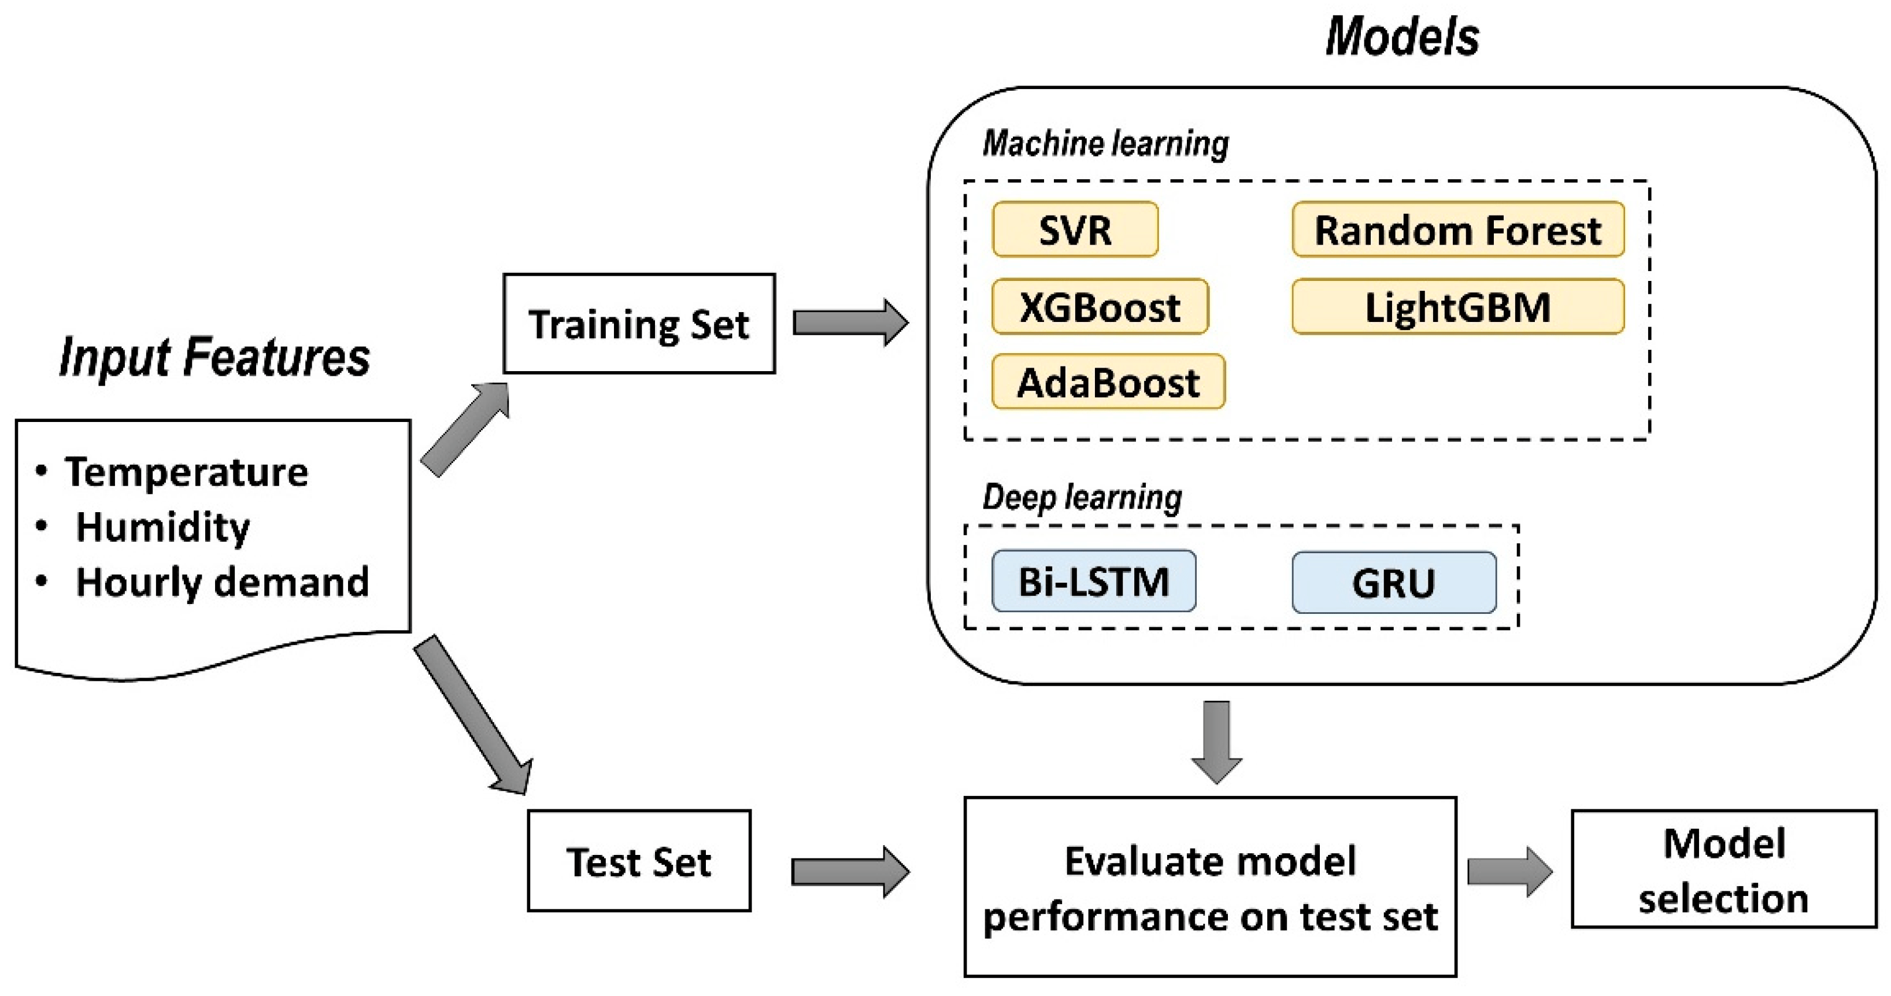

**Figure 1.** Experiment for Short-Term Electricity Demand Forecasting.

Deep learning regression mapped the nonlinear relationship between the input features and the output (electricity demand). Several input features were considered to predict demand: month, day of the week, hour of the day, temperature, and relative humidity. The first node of the workflow is the File Reader, which reads the .csv file that contains the input data. The dataset is then divided into a training (80%) and test set (20%) using the Partitioning node. Next, the training data are normalized between 0 and 1 using the Normalizer node. The test set was then normalized according to the normalization parameters learned from the training set using the Normalizer (Apply) node. It was important to normalize the data since all the input features have different scaling ranges, which can affect the training of the machine learning models. Therefore, normalizing the data between 0 and 1 makes each input feature equally important.

In our capstone project, we will use  **deep learning** (Keras' Sequential model).

**5.** **Architecture Design Diagram**

* Provide a high-level overview of the architecture of your project.
  + Use a diagram to illustrate the key components and their interactions.
* Briefly describe each component shown in the diagram
  + Highlighting their roles and functionalities within the overall system.

Figure 1 is normally the diagram that we want to use in our project but unfortunately we did not find a dataset providing all these inputs. Here is the new diagram:



Use of predictions

tau1, tau2, tau3...g1, g2

Deep Learning (Kera’s Sequential model)

**20%**

**80 %**

In our input features we have : tau1(Reaction time - Energy producer), tau2(Reaction time - Consumer 1), tau3(Reaction time - Consumer 2), tau4(Reaction time - Consumer 3), p1(Power balance - Energy producer), p2(Power balance - Consumer 1), p3(Power balance - Consumer 2), p4(Power balance - Consumer 3), g1(Price elasticity coefficient (gamma) - Energy producer), g2(Price elasticity coefficient (gamma) - Consumer 1)

1. **Data Sources**

The original dataset contains 10,000 observations. As the reference grid is symetric, the dataset can be augmented in 3! (3 factorial) times, or 6 times, representing a permutation of the three consumers occupying three consumer nodes. The augmented version has then **60,000 observations**. It also contains **12 primary predictive features** and two dependent variables.

**The predictions from features will be used to help customer and operator to set Smart Grid Stability and avoid waste.**

1. **Literature Review**

**Implementation Plan**

1. **Technology Stack**

At term our goal is to provide an mobile app that can handle the input and prediction for customer and operator. For now, we will use a website solution with **flash. So, we have:**

**Jupyter Note, Python, Numpy, Keras...**

**2. Timeline**

* Different stages of project,
  + Data collection and pre-processing : 2/12/2023-3/12/2023
  + Model development 4/12/2023-5/12/2023
  + Training, and evaluation 6/12/2023-8/12/2023
  + Deployment 9/12/2023-10/12/2023



1. **Milestones**
2. Prediction Model done
3. Test
4. Deployment
5. Website test and feedback

**4. Challenges and Mitigations**

* Anticipate potential challenges that may arise during the project and propose strategies for mitigating them.
  + Data quality
  + Model performance
  + Technical constraints.

Data quality, we will use a dataset which is not very complete and which switch slightly our project purpose. Technical constraints because we won’t be able to receive data and implement it in a smart grid...

1. **Ethical Considerations**

All data used in the project won’t impact privacy of user. But smart grid because using a network can be attacked and provide serious problems.

**6. References**